Department of BES-1
DATA STRUCTURES THROUGH PYTHON(24SC1204)
I/IV-B.Tech-(II Sem), Academic Year: 2024-2025
Session-33 ( Red and Black Trees)
Instructional Objective:
- To learn the concept Red and Black Trees
- To find the solution and implementation of Red and Black Tree
Learning Outcomes:
- Able to solve the problems on B-Trees
- Able to solve the problem on Red and Black Trees

3.4.3: Red and Black Tree Construction
What is red-black tree structure?
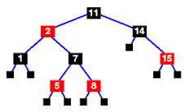
A red-black tree is a binary search tree which has the following red-black properties: Every node is either red or black. Every leaf (NULL) is black. If a node is red, then both its children are black. Every simple path from a node to a descendant leaf contains the same number of black nodes.

A red-black tree is a binary search tree with one extra attribute for each node: the colour, which is either red or black. We also need to keep track of the parent of each node, so that a red-black tree's node structure would be:
struct t_red_black_node {
enum { red, black } colour;
void *item;
struct t_red_black_node *left,
*right,
*parent;
}
For the purpose of this discussion, the NULL nodes which terminate the tree are considered to be the leaves and are coloured black.

Definition of a red-black tree
A red-black tree is a binary search tree which has the following red-black properties:
- Every node is either red or black.  - Every leaf (NULL) is black.  - If a node is red, then both its children are black.  - Every simple path from a node to a descendant leaf contains the same number of black nodes. | - implies that on any path from the root to a leaf, red nodes must not be adjacent.  However, any number of black nodes may appear in a sequence.

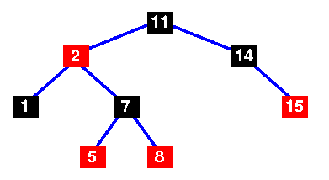 | A basic red-black tree
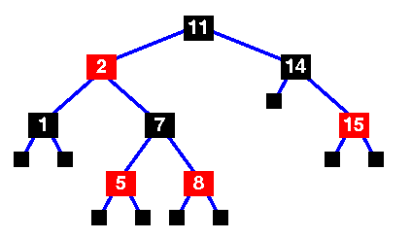 | Basic red-black tree with the sentinel nodes added. Implementations of the red-black tree algorithms will usually include the sentinel nodes as a convenient means of flagging that you have reached a leaf node.  They are the NULL black nodes of property 2.
The number of black nodes on any path from, but not including, a node x to a leaf is called the black-height of a node, denoted bh(x). We can prove the following lemma:

Lemma
A red-black tree with n internal nodes has height at most 2log(n+1).
(For a proof, see Cormen, p 264)
This demonstrates why the red-black tree is a good search tree: it can always be searched in O(log n) time.
As with heaps, additions and deletions from red-black trees destroy the red-black property, so we need to restore it. To do this we need to look at some operations on red-black trees.

Rotations
A rotation is a local operation in a search tree that preserves in-order traversal key ordering.  Note that in both trees, an in-order traversal yields:  A x B y C | 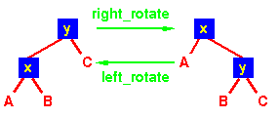

How do you make a black and red tree?
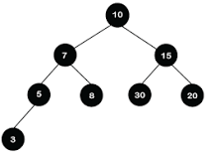
The following are some rules used to create the Red-Black tree: If the tree is empty, then we create a new node as a root node with the color black. If the tree is not empty, then we create a new node as a leaf node with a color red. If the parent of a new node is black, then exit.

How are red-black trees implemented?
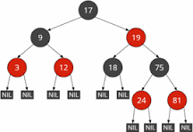
To implement the red-black tree, besides the child nodes left and right , we need a reference to the parent node and the node's color. We store the color in a boolean , defining red as false and black as true . We implement the red-black tree in the RedBlackTree

Why is it called a red-black tree?
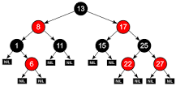
Balanced binary search trees are much more efficient at search than unbalanced binary search trees, so the complexity needed to maintain balance is often worth it. They are called red-black trees because each node in the tree is labeled as red or black.

What are the disadvantages of red-black tree?
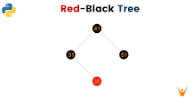
Disadvantages of Red-Black Tree
- Relatively complicated to implement.
- The red-black tree is not rigidly balanced in comparison to the AVL tree.
What are the five properties of red-black tree?
Red-Black Trees have the following properties:
- Every node has a color.
- The root is black.
- Every leaf is a special node called NIL (with no key)
- NIL is black.
- If a node is red, then it's children are black [ie no 2 red trees in a row]
- Every path from root to leaf has the same number of black nodes.

A red-black tree is a kind of self-balancing binary search tree where each node has an extra bit, and that bit is often interpreted as the color (red or black). These colors are used to ensure that the tree remains balanced during insertions and deletions. Although the balance of the tree is not perfect, it is good enough to reduce the searching time and maintain it around O(log n) time, where n is the total number of elements in the tree. This tree was invented in 1972 by Rudolf Bayer.
It must be noted that as each node requires only 1 bit of space to store the color information, these types of trees show identical memory footprints to the classic (uncolored) binary search tree.

Rules That Every Red-Black Tree Follows:
- Every node has a color either red or black.
- The root of the tree is always black.
- There are no two adjacent red nodes (A red node cannot have a red parent or red child).
- Every path from a node (including root) to any of its descendants NULL nodes has the same number of black nodes.
- All leaf nodes are black nodes.

Why Red-Black Trees?
Most of the BST operations (e.g., search, max, min, insert, delete.. etc) take O(h) time where h is the height of the BST. The cost of these operations may become O(n) for a skewed Binary tree. If we make sure that the height of the tree remains O(log n) after every insertion and deletion, then we can guarantee an upper bound of O(log n) for all these operations. The height of a Red-Black tree is always O(log n) where n is the number of nodes in the tree.
Sr. No. | Algorithm | Time Complexity
1. | Search | O(log n)
2. | Insert | O(log n)
3. | Delete | O(log n)
“n” is the total number of elements in the red-black tree.
Comparison with AVL Tree:
The AVL trees are more balanced compared to Red-Black Trees, but they may cause more rotations during insertion and deletion. So if your application involves frequent insertions and deletions, then Red-Black trees should be preferred. And if the insertions and deletions are less frequent and search is a more frequent operation, then AVL tree should be preferred over the Red-Black Tree.
How does a Red-Black Tree ensure balance?
A simple example to understand balancing is, that a chain of 3 nodes is not possible in the Red-Black tree. We can try any combination of colors and see if all of them violate the Red-Black tree property.

Session-31 and 33 (B-Tree and Red Black Trees)
Instructional Objective:
- To learn the concept of B-Tree and Red Black Trees
- To find the solution and implementation of B-Tree and red Black Tree
Learning Outcomes:
- Able to solve the problems on B-Trees
- Able to solve the problem on Red and Black Trees

3.4.1: MCQ on B-Tree
1. Which of the following is the most widely used external memory data structure?
a) AVL tree
b) B-tree
c) Red-black tree
d) Both AVL tree and Red-black tree
Ans: b
2. B-tree of order n is a order-n multiway tree in which each non-root node contains __________
a) at most (n – 1)/2 keys
b) exact (n – 1)/2 keys
c) at least 2n keys
d) at least (n – 1)/2 keys
Ans: d

3. A B-tree of order 4 and of height 3 will have a maximum of _______ keys.
a) 255
b) 63
c) 127
d) 188
Ans: a
4. Five node splitting operations occurred when an entry is inserted into a B-tree. Then how many nodes are written?
a) 14
b) 7
c) 11
d) 5
Ans: c
5. B-tree and AVL tree have the same worst case time complexity for insertion and deletion.
a) True
b) False
Ans: a
6. 2-3-4 trees are B-trees of order 4. They are an isometric of _____ trees.
a) AVL
b) AA
c) 2-3
d) Red-Black
Ans: d
7. What is the best case height of a B-tree of order n and which has k keys?
a) logn (k+1) – 1
b) nk
c) log_{k} (n+1) – 1
d) klog_{n}
Ans: a
8. Which of the following is true?
a) larger the order of B-tree, less frequently the split occurs
b) larger the order of B-tree, more frequently the split occurs
c) smaller the order of B-tree, more frequently the split occurs
d) smaller the order of B-tree, less frequently the split occurs
Ans: a
9. Which of the following is true?
a) B + tree allows only the rapid random access
b) B + tree allows only the rapid sequential access
c) B + tree allows rapid random access as well as rapid sequential access
d) B + tree allows rapid random access and slower sequential access
Ans: c
10. A B+ tree can contain a maximum of 7 pointers in a node. What is the minimum number of keys in leaves?
a) 6
b) 3
c) 4
d) 7
Ans: b
11. Efficiency of finding the next record in B+ tree is ____
a) O(n)
b) O(log n)
c) O(nlog n)
d) O(1)
Ans: d
12. What is the maximum number of keys that a B+ -tree of order 3 and of height 3 have?
a) 3
b) 80
c) 27
d) 26
Ans: d
13. . Which of the following is false?
a) Compared to B-tree, B+ -tree has larger fanout
b) Deletion in B-tree is more complicated than in B+ -tree
c) B+ -tree has greater depth than corresponding B-tree
d) Both B-tree and B+ -tree have same search and insertion efficiencies
Ans: c
14. Which one of the following data structures are preferred in database-system implementation?
a) AVL tree
b) B-tree
c) B+ -tree
d) Splay tree
Ans: c
15. 2-3 tree is a specific form of _________
a) B – tree
b) B+ – tree
c) AVL tree
d) Heap
Ans: a

16. The height of 2-3 tree with n elements is ______
a) between (n/2) and (n/3)
b) (n/6)
c) between (n) and log2(n + 1)
d) between log3(n + 1) and log2(n + 1)
Ans: d

17. Which of the following the BST is isometric with the 2-3 tree?
a) Splay tree
b) AA tree
c) Heap
d) Red – Black tree
Ans: b
18. Which of the following data structure can provide efficient searching of the elements?
a) unordered lists
b) binary search tree
c) treap
d) 2-3 tree
Ans: d
19. Which of the following is not true about the 2-3 tree?
a) all leaves are at the same level
b) it is perfectly balanced
c) postorder traversal yields elements in sorted order
d) it is B-tree of order 3
Ans: c
20. Which of the following is false?
a) 2-3 tree requires less storage than the BST
b) lookup in 2-3 tree is more efficient than in BST
c) 2-3 tree is shallower than BST
d) 2-3 tree is a balanced tree
Ans: a

Session-31 ( B- Trees)
Instructional Objective:
- To learn the concept B- Trees
- To find the solution and implementation of Red and Black Tree
Learning Outcomes:
- Able to solve the problems on B-Trees

3.4.1: B-Tree Home Assignment Questions
Question: What is B-Tree ? Describe with proper syntax and example

Session-31 and 33 ( Red and Black Trees)
Instructional Objective:
- To learn the concept Red and Black Trees
- To find the solution and implementation of Red and Black Tree
Learning Outcomes:
- Able to solve the problems on B-Trees
- Able to solve the problem on Red and Black Trees

3.4.3: Red and Back Tree Home Assignment Questions
Question: What is Red and Black tree? What do you mean by red and black colors in Red and black tree?

